### 



### Harbour Investment Horizons



### NZ housing market outlook and chart pack

**Investment Research**

11 November 2013 | christian@harbourasset.co.nz +64 4 460 8309

The NZ housing market has come back to life in 2013, and is an important ingredient in the economic outlook for 2014. This note summarizes our assessment of the housing market, and contains a chart pack of key indicators.

In the short-term, mortgage approvals and housing sales should provide the best leading indicator of the impact of the LVR restrictions imposed by the RBNZ. In the long-term, we believe that affordability will be a key factor restraining NZ house price inflation.

* **House price inflation:** NZ house price inflation has increased by nearly 10% in 2013. While nation-wide house price inflation remains below the peaks of the mid-2000s, there is considerable regional dispersion. In particular, Auckland is experiencing annual house price inflation of nearly 20%.
* **Supply and demand drivers:** One of the key drivers of higher house prices is the lack of residential building between 2008 and 2012, which created a shortage of housing supply. During that period, there were less than 15,000 new houses built per year (and less than 4,000 per year in Auckland). Another factor supporting house prices has been a pick-up in demand as net migration has turned around since 2012, especially net migration versus Australia.
* **Government policy:** In May the government and Auckland Council announced a plan to enable 39,000 new homes to be built in Auckland over the next three years, with a target of 9,000 in Year 1, 13,000 in Year 2 and 17,000 in Year 3. This is an ambitious plan given that Auckland house building peaked in 2003 with 12,000 homes built.
* **The role of credit:** While household credit growth has picked up to around 5% per annum, it is still relatively modest compared to the mid 2000s when annual credit growth exceeded 15%. So it is hard to argue that 2013 has seen a “credit fuelled” house price boom. However, the percentage of riskier high loan-to-value mortgages (over 80% LVR) has increased to around 30% of new lending, suggesting a growing exposure of some banks and mortgage borrowers to a housing market downturn.
* **The RBNZ policy response:** This pick-up in high LVR lending prompted the RBNZ’s new speed limit of no more than 10% of new mortgage lending having an LVR over 80%. While announced in August, this came into force in October. The RBNZ also signalled in their September *Monetary Policy Statement* their willingness to increase official interest rates in 2014. This helped pushed up longer-term fixed rates, with 3 year mortgage rates rising around 0.70% from their lows to around 6.5%.
* **Uncharted territory:** Introducing LVR restriction is unchartered territory for New Zealand, and overseas evidence of the effectiveness of macro-prudential tools is mixed. The RBNZ estimates that LVR restrictions are likely to lower annual household credit growth by 1 to 3 percentage points. However, the new rules could introduce some unusual dynamics. For example, aspiring high LVR borrowers with an existing pre-approval could rush to take out a mortgage before their pre-approval expires. Equally, banks could attempt to increase the growth of their low LVR lending (with increased total lending creating more headroom for high LVR within the 10% speed limit).
* **Initial response of banks and borrowers:** Our intelligence suggests that the initial response of banks has been to pull back significantly from high LVR lending. Part of this caution relates to banks needing more time to come to grips with implementing and monitoring compliance to the new rules. Until then, they have a strong aversion to being anywhere near their 10% limit. While data on new mortgage approvals is volatile on a weekly basis, approvals have trended down since the RBNZ announced its LVR restrictions. Surveys of housing confidence also suggest that sentiment in the housing market is becoming more cautious, especially in Auckland where a net 20% or respondents believe it is not a good time to buy.
* **Affordability:** While the new LVR rule may help cool the housing market in the short-to-medium term, affordability should help restrain the market in the long-term. The house price to disposable income ratio in New Zealand is still elevated at around 4.5. This is not only high by historic standards but the IMF, OCED and rating agencies all highlight that it is also high by international standards. Debt servicing costs in New Zealand have been eased by record low mortgage rates, but could start to bite in a rising interest rate environment.
* **House price forecasts:** In their September Monetary Policy Statement, the RBNZ forecast annual house price inflation to moderate to around 3.5% per year by 2015. Many private sector bank economists also have low forecasts of house price inflation, as they pick house prices to take a breather after a strong run.

In our view, mortgage approvals and housing sales should provide the best short-term leading indicator of the impact of the RBNZ’s LVR restrictions. In the long-term, we believe that affordability will be a key factor restraining NZ house price inflation.

***Christian Hawkesby***

*Director, Fixed Interest*

*Harbour Asset Management*

**ANNEX 1. NZ housing market chart pack**

NZ house price inflation has increased, but remains much lower than the mid 2000s…

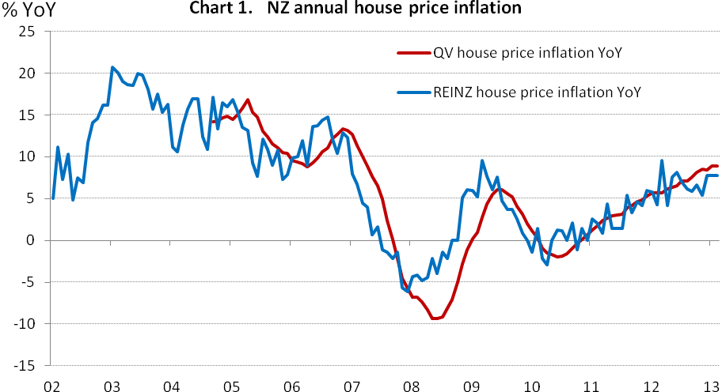

Source: REINZ and Quotable Value NZ

However, there is considerable regional dispersion, and Auckland arguably overheating…

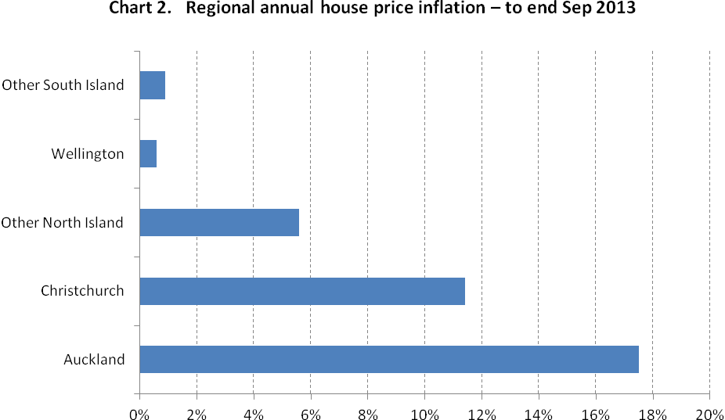

Source: REINZ.

One of the drivers of higher house prices is the lack of house building between 2008 and 2012, creating a shortage of supply...

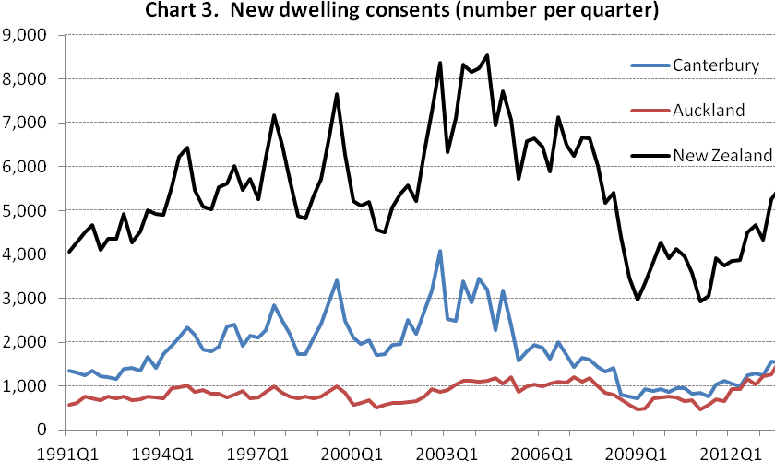

Source: Statistics New Zealand.

Another factor is a pick-up in housing demand as net migration has turned around since 2012, particularly as kiwis have returned from Australia...

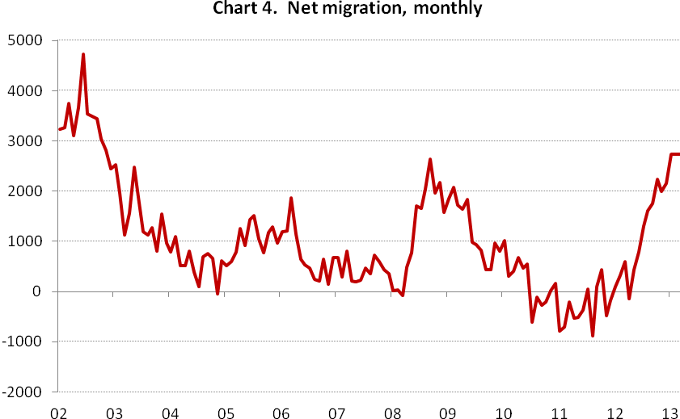

Source: Statistics New Zealand.

While credit growth has picked up, it is still relatively modest compared to the mid 2000s, suggesting this hasn’t yet been a “credit fuelled” housing boom...

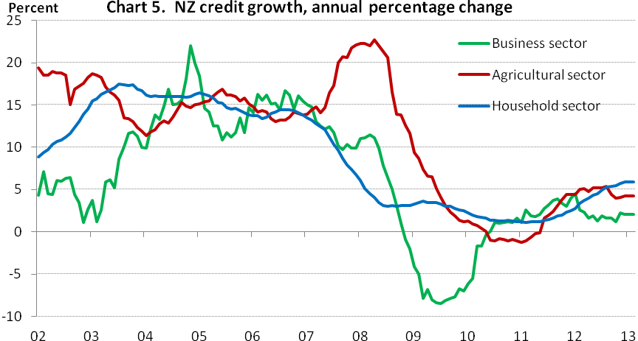

Source: RBNZ.

However, the percentage of risky high loan-to-value mortgage (over 80%) has increased, suggesting an increasing exposure of some banks and mortgage borrowers to a housing market downturn. This prompted the RBNZ’s new speed limit rule.

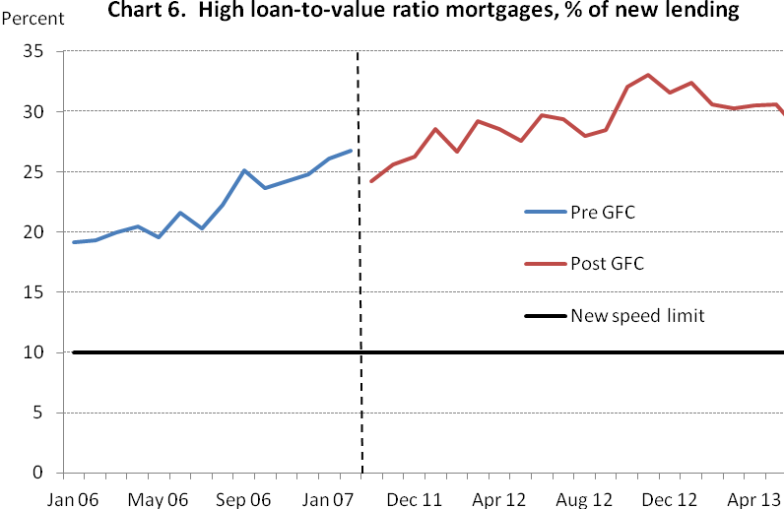

Source: RBNZ. Based on private reporting by 8 registered banks.

The RBNZ have also signalled their willingness to increase official interest rates in 2014, which has pushed up longer-term fixed rates, in part helping to cool the housing market.

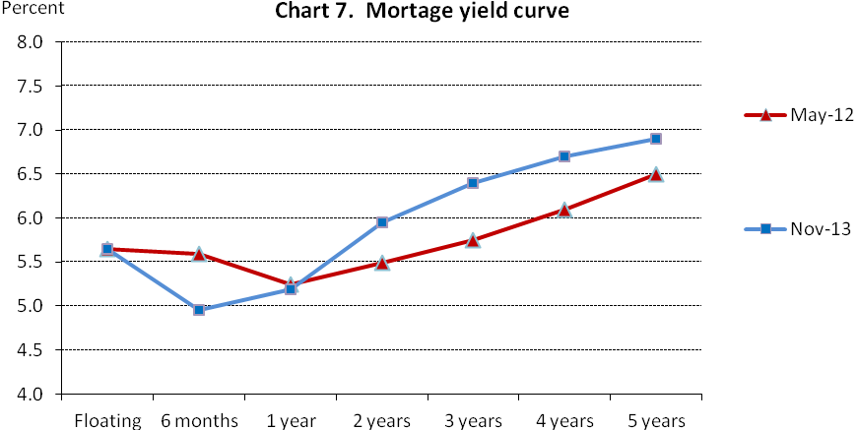

Source: Interest.co.nz. The lowest standard rates available from ANZ, ASB, BNZ, Westpac or Kiwibank.

While data on new mortgage approvals is volatile on a weekly basis, approvals have trended down since the RBNZ announced its LVR restrictions.

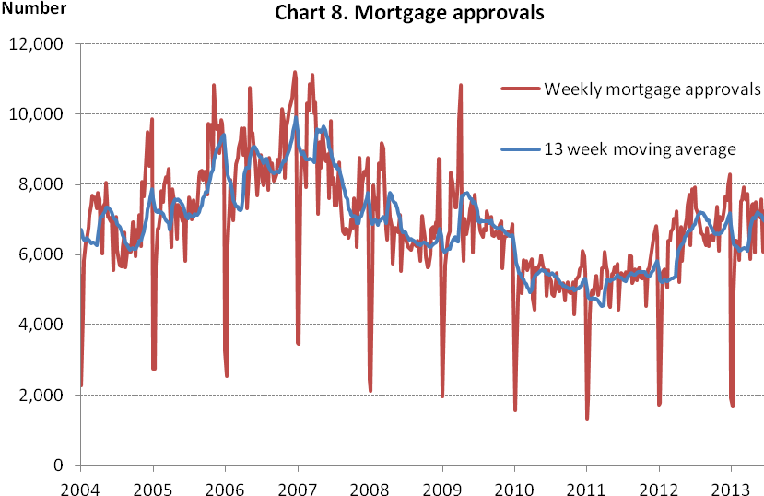

Source: RBNZ.

Surveys of housing market confidence also suggest that sentiment in the housing market is becoming more cautious, especially in Auckland...

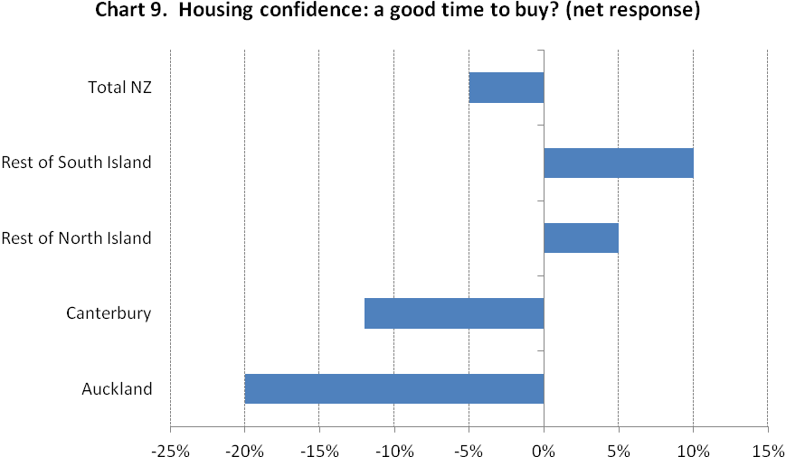

Source: ASB. October survey.

While LVR may help restrain the housing market in the short-to-medium term, affordability should help restrain the market in the long-term. House prices to income are still elevated in New Zealand....

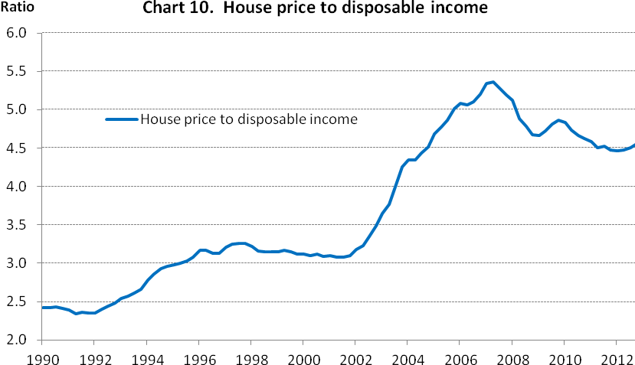

Source: RBNZ, Property IQ, Statistics NZ, Department of Building and Housing.

Debt servicing costs are also more likely to bite on the housing market in a rising interest rate environment...

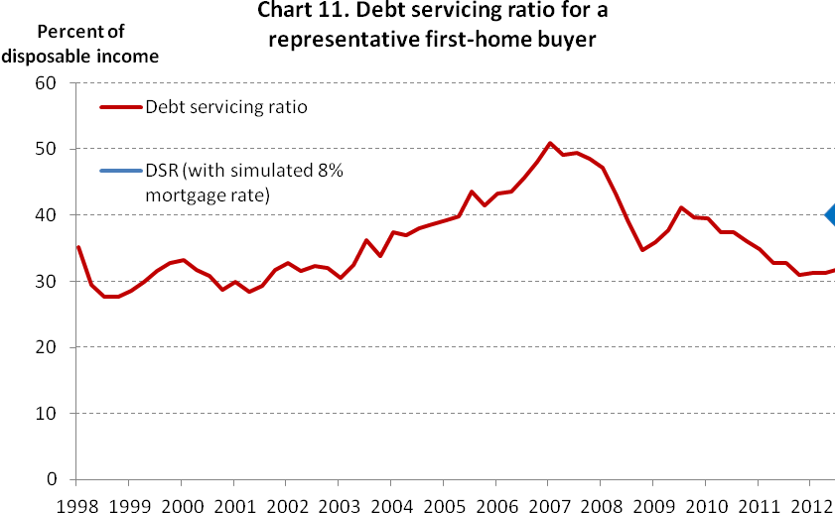

Source: Quotable Value NZ, Statistics New Zealand, and RBNZ calculations.

The RBNZ forecast annual house price inflation to moderate to around 3-4% by 2015…

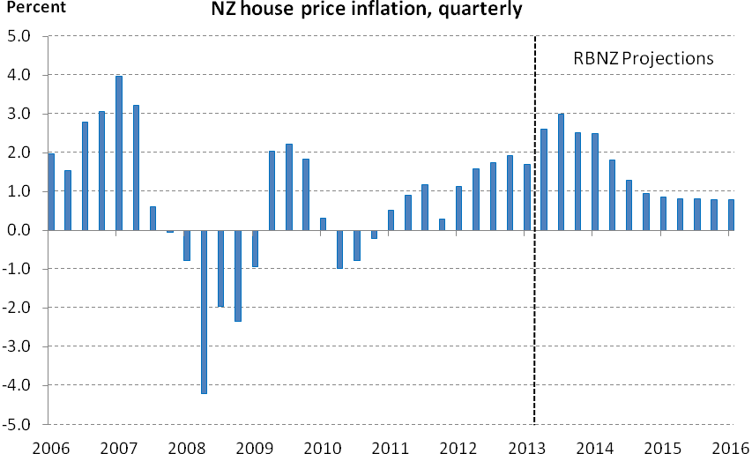

Source: Property IQ and RBNZ estimates.

*IMPORTANT NOTICE AND DISCLAIMER*

*The Harbour Investment Horizon is given in good faith and has been prepared from published information and other sources believed to be reliable, accurate and complete at the time of preparation but its accuracy and completeness is not guaranteed. Information and any analysis, opinions or views contained herein reflect a judgement at the date of preparation and are subject to change without notice. The information and any analysis, opinions or views made or referred to is for general information purposes only. To the extent that any such contents constitute advice, they do not take into account any person’s particular financial situation or goals, and accordingly, do not constitute personalised financial advice under the Financial Advisers Act 2008, nor do they constitute advice of a legal, tax, accounting or other nature to any person.. The bond market is volatile. The price, value and income derived from investments may fluctuate in that values can go down as well as up and investors may get back less than originally invested. Past performance is not indicative of future results, and no representation or warranty, express or implied, is made regarding future performance. Bonds and bond funds carry interest rate risk (as interest rates rise, bond prices usually fall, and vice versa), inflation risk and issuer credit and default risks. Where an investment is denominated in a foreign currency, changes in rates of exchange may have an adverse effect on the value, price or income of the investment. Reference to taxation or the impact of taxation does not constitute tax advice. The rules on and bases of taxation can change. The value of any tax reliefs will depend on your circumstances. You should consult your tax adviser in order to understand the impact of investment decisions on your tax position. To the maximum extent permitted by law, no liability or responsibility is accepted for any loss or damage, direct or consequential, arising from or in connection with this document or its contents. Actual performance of investments managed by Harbour Asset Management Limited will be affected by management charges. No person guarantees the performance of funds managed by Harbour Asset Management Limited.*